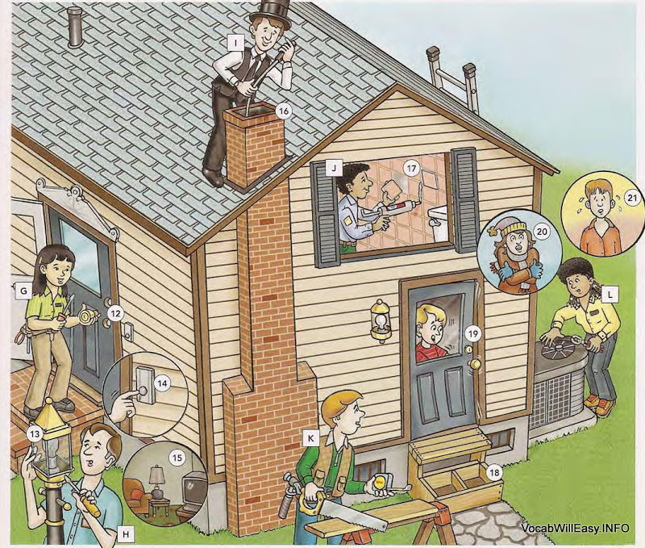
G locksmith  12 The lock is broken.  H electrician  13 The front light doesn’t go on.  14 The doorbell doesn’t ring.  15 The power is out in the living room.  I chimneysweep  16 The chimney is dirty. | J home repairperson / “handyman”  17 The tiles in the bathroom are loose.  K carpenter  18 The steps are broken.  19 The door doesn’t open.  L heating and air conditioning service  20 The heating system is broken.  21 The air conditioning isn’t working.

